**Original Ticket Description**

Context menu option only avail for global and local admin

Need to provide an option to select projects by checkbox in the grid and mark for archive.

"By marking this project for archiving, the data of this project will be stored permanently on the archiving server and the project is permanently removed from the NIMT user interface. This is not reversible; do you wish to continue?"

Then implement a running process executed once a month to remove archived server.

Ensure with the analytics team that projects flagged with archive=1 are never removed from the archiving server.

Logical steps are as follows:

1. user or procedure marks a project as "ready for archive" archive flag=1. (only closed projects)
2. the procedure to update the archiving server is running on a daily basis, and has then also identified this a project to be archived archived flag=1 as a part of the incremental update
3. only once the project archive flag (=1) is synced to the archiving server, the project is then ready to be deleted. The archiving server update job should trigger the delete in this case.
4. Deletion also includes all project information:
   1. collaboration
   2. risk
   3. schedule etc.

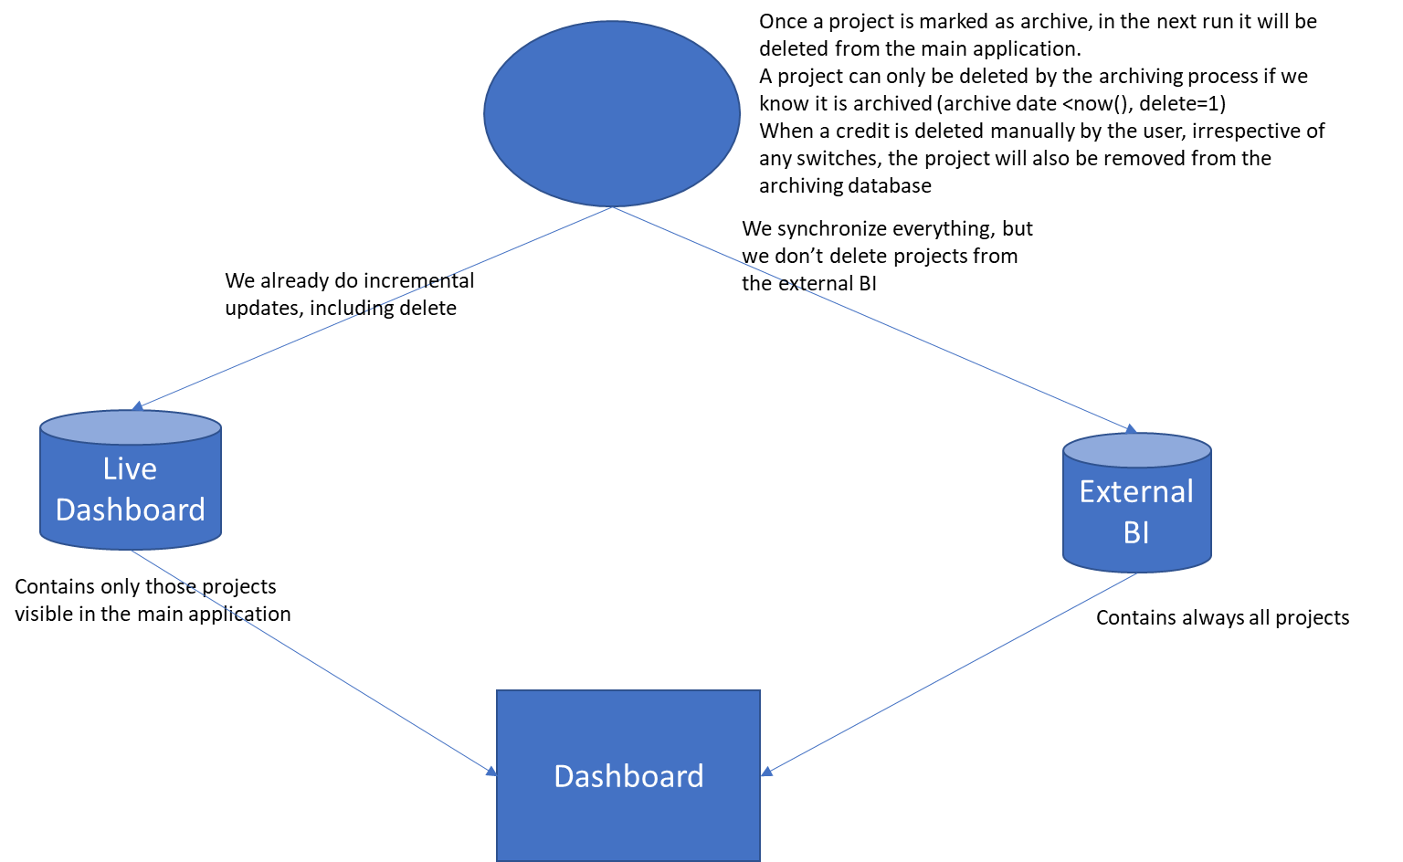

**Implementation**

A setting has been added on cc.aspx to flag the visibility of the functionality.

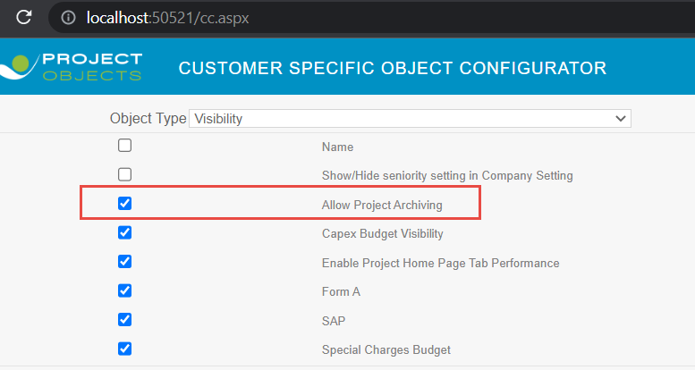

An icon has been added on the project listing to mark the projects (state-closed) as archived.

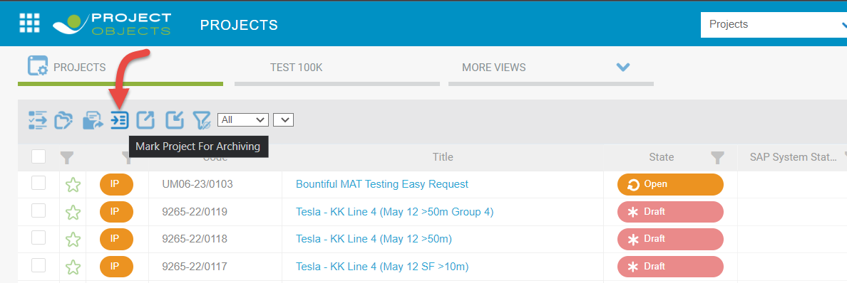

The icon will be visible to Local and Global Admins.

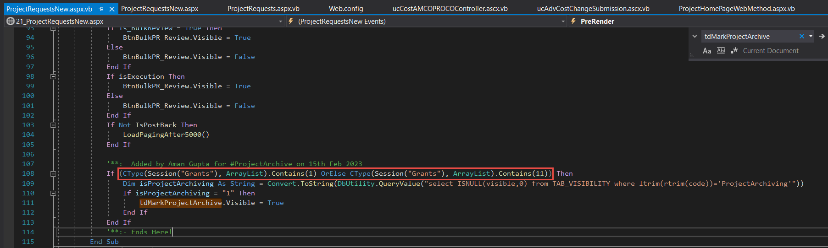

User needs to select the eligible project from the register then, after clicking on the icon. All selected projects will be marked as achieved.

By archiving we mean inserting the project into ARCHIEVED_PROJECTS table, and hiding it from the UI by setting its F_MODELLO = 1.

Project can also be marked as archived from context menu, besides the icon on register.

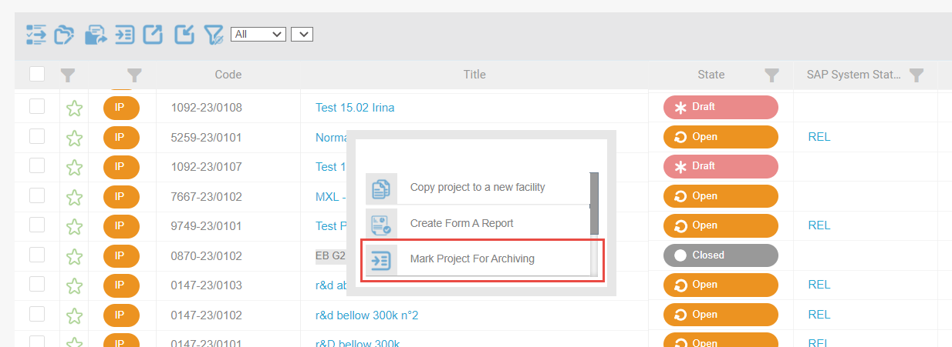

Once the project is marked as archived, it will no longer be visible on the application.

A procedure has also been developed to delete all the related items with the archived project.

NestlePO10\Scripts\2023\January\Project Archieve\RemoveArchivedProjects.sql

**Availability**

This is available on NIMT Beta, NIMT Pre-prod, and NIMT Livetrial.